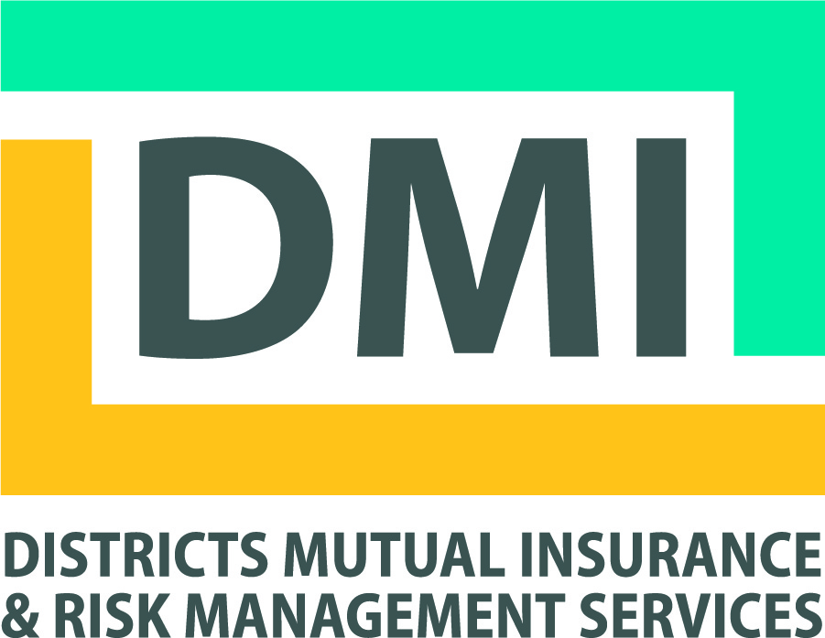
Contact Information

Name:
Technical College:
If Other:
Email Address:
Telephone Number:

Attending
(Please check all that apply)
Special Requirements (ie: dietary, mobility, etc.)
Wednesday, April 19, 2017
Thursday, April 20, 2017
Friday, April 21, 2017

Onsite Check In: Wednesday, April 19 12:30 pm – 1:00 pm – In Foyer of Palm Garden Rooms
Thursday, April 20 7:00 am – 7:30 am – In Foyer of Palm Garden Rooms

Wednesday April 19 1:00 pm – 4:45 pm (Room)
Risk Managers Meeting – Steven Stoeger-Moore / Joe Des Plaines (Palm Garden F)
Environmental Health & Safety / Campus Security Meeting – Tim Greene / Tim McNulty (Palm Garden B/C)
Not Attending

Session Choices
(Please select a session from each time slot below. Note: Sessions on Thursday and Friday are repeated for optimal attendance.)

Thursday April 20 7:00 am – 9:00 am
Breakfast / Welcome – Keynote Address Getting A Seat For Risk Discussions At The Table. Gary Langsdale, Pennsylvania State University (Palm Garden B/C)
Not Attending

Thursday April 20 9:15 am – 10:15 am
You Want To Do WHAT? Gary Langsdale, Pennsylvania State University (Elkhart Ballroom A)
Worker Compensation Cases, Why Some Are Won And Some Are Lost? Paul Riegel, Riegel Law SC (Palm Garden E)
Campus Security Department Best Practices Dan Jacobson, Northcentral Technical College (Palm Garden F)
The Cyber Risk Landscape and Impact on Technical Colleges Mark Greisiger, NetDiligence (Elkhart Ballroom B)
Not Attending

Thursday April 20 10:20 am – 11:20 am (Room)
You Want To Do WHAT? Gary Langsdale, Pennsylvania State University (Elkhart Ballroom A)
Worker Compensation Cases, Why Some Are Won And Some Are Lost? Paul Riegel, Riegel Law SC (Palm Garden E)
Campus Security Department Best Practices Dan Jacobson, Northcentral Technical College (Palm Garden F)
The Cyber Risk Landscape and Impact on Technical Colleges Mark Greisiger, NetDiligence (Elkhart Ballroom B)

Thursday April 20 11:30 am – 11:50 am
DMI Annual Meeting / Election of DMI BOD Members Rob Mulcahy, Michael Best (Palm Garden B/C)
Not Attending

Thursday April 20 11:50 am – 12:45 am
Lunch (Palm Garden B/C)
Not Attending

Thursday April 20 12:50 pm – 1:50 pm
Hot Topics in Higher Education - Legal Rob Mulcahy & Joseph Olson, Michael Best (Elkhart Ballroom A)
Environmental Crisis on Campus - How to Prepare and Respond D’Arcy Gravelle, Key Engineering (Palm Garden E)
The Importance of a Causality Care Program Christopher Wistom MD, Mercy Hospital (Palm Garden F)
FBI’s Role in Cyber Security Byron Franz, US Federal Bureau of Investigations (FBI) (Elkhart Ballroom B)
Not Attending

Thursday April 20 1:55 pm – 2:55 pm
Hot Topics in Higher Education – Legal Rob Mulcahy & Joseph Olson, Michael Best (Elkhart Ballroom A)
Environmental Crisis on Campus - How to Prepare and Respond D’Arcy Gravelle, Key Engineering (Palm Garden E)
The Importance of a Causality Care Program Christopher Wistom MD, Mercy Hospital (Palm Garden F)
FBI’s Role in Cyber Security Byron Franz, US Federal Bureau of Investigations (FBI) (Elkhart Ballroom B)
Not Attending

Thursday April 20 3:00 pm – 4:00 pm
Managing the Risk of Minors on Campus Aaron Lundberg, Praesidium (Elkhart Ballroom A)
Workers Compensation Causation Evaluation Process Tom Yoss, United Heartland (Palm Garden E)
The Importance of Violence Prevention Training Pam Roncone, Crisis Prevention Institute (CPI) (Palm Garden F)
Lessons Learned From Recent Crisis Call Center Activation Andrea Chiroff, Empathia (Elkhart Ballroom B)
Not Attending

Thursday April 20 4:05 pm – 5:05 pm
Managing the Risk of Minors on Campus Aaron Lundberg, Praesidium (Elkhart Ballroom A)
Workers Compensation Causation Evaluation Process Tom Yoss, United Heartland (Palm Garden E)
The Importance of Violence Prevention Training Pam Roncone, Crisis Prevention Institute (CPI) (Palm Garden F)
Lessons Learned From Recent Crisis Call Center Activation Andrea Chiroff, Empathia (Elkhart Ballroom B)
Not Attending

Thursday April 20 6:00 pm – 8:00 pm
Cash Bar / Social Networking / Dinner / Foundation Checks and Awards (Villa Gottfired Room)
Not Attending

Friday April 21 7:30 am – 9:00 am (Room)
Breakfast / Welcome (Palm Garden B/C)
Not Attending

Friday April 21 9:05 am – 10:05 am
Everything You've Always Wanted to Know About URMIA & MORE! Jennifer Whittington, URMIA (Elkhart Ballroom A)
Updates & How DSPS Differs from OSHA Ann Jurkowski, WI Dept of Safety & Professional Services (DSPS) (Palm Garden E)
Is the College Insured for That? Steven Stoeger Moore, Districts Mutual Insurance & Risk Mgmt. Services (Palm Garden F)
Lessons Learned from ServiceMaster Crisis Response Mark Cyganiak, Service Master (Elkhart Ballroom B)
Not Attending

Friday April 21 10:10 am – 11:10 am
Everything You've Always Wanted to Know About URMIA & MORE! Jennifer Whittington, URMIA (Elkhart Ballroom A)
Updates & How DSPS Differs from OSHA Ann Jurkowski, WI Dept of Safety & Professional Services (DSPS) (Palm Garden E)
Is the College Insured for That? Steven Stoeger Moore, Districts Mutual Insurance & Risk Mgmt. Services (Palm Garden F)
Lessons Learned from ServiceMaster Crisis Response Mark Cyganiak, Service Master (Elkhart Ballroom B)
Not Attending

Friday April 21 11:30 am – 12:45 pm
Closing Keynote Address Charlie Kingdollar, General Reinsurance Corp. (Elkhart Ballroom A&B)
Not Attending

E-mail Registration Forms to Suzette Harrell at suzette@districtsmutualinsurance.com
No Later than April 12, 2017.
This will allow us to confirm attendance for all meal and meeting room requirements.

Additional registration forms and “Session Descriptions” can be found on the DMI website at: www.districtsmutualinsurance.com, in the “Meetings” tab, under
Risk Mitigation Forum and Annual Meeting. (Password is not required to access.)

If you have questions regarding the conference, please contact Tim Greene by phone or at tim@districtsmutualinsurance.com

