Employee Accident Investigation Report

Instructions to Employee

Use this form to report all work-related injuries, illnesses, or near-miss events (which could have caused an injury or illness), no matter how minor. This helps us to identify and correct hazards before they cause serious injuries. Complete this form as soon as possible and give it to your supervisor for further action.

Type of Report |  | ☐ Injury | ☐ Illness | ☐ Near Miss
Your Name Click or tap here to enter text.
Job Title Click or tap here to enter text.
Supervisor’s Name Click or tap here to enter text.
Has your supervisor been informed of the incident? |  |  | ☐ Yes | ☐ No
Date & Time of Incident: Click or tap here to enter text.
Location of Incident: Click or tap here to enter text.
Witnesses (if any) Click or tap here to enter text.
What were you doing at the time?
Click or tap here to enter text.
Describe step-by-step what led up to the incident.
Click or tap here to enter text.
What could have been done to prevent this incident?
Click or tap here to enter text.
What parts of your body were injured?
Click or tap here to enter text.
If a near miss, how could you have been hurt?
Click or tap here to enter text.
Did you see a doctor about this incident? |  | ☐ Yes, see below |  | ☐ No
Name and phone number of treating physician.
Click or tap here to enter text.
Date and time of appointment. Click or tap here to enter text.
Has this part of your body been injured before? |  |  | ☐ Yes | ☐ No
If yes, When? (Date)
Click or tap here to enter text.

Employee Signature:

Name (Print): Click or tap here to enter text.

Date: Click or tap here to enter text.

Instructions to Supervisors

Complete this form as soon as possible after an incident that results in serious injury or illness. (Optional: Use to investigate a minor injury or new miss that could have resulted in a serious injury or illness.)

Type of Report | ☐ Injury | ☐ Illness |  | ☐ Near Miss | ☐ Death
Name of Injured Person  Click or tap here to enter text. |  | Gender |  | ☐ Male | ☐ Female
Date of Birth Click or tap here to enter text. Phone Number Click or tap here to enter text.
Position & Department Click or tap here to enter text.
Status ☐ Regular Full-Time ☐ Regular Part Time ☐ Seasonal ☐ Temporary
Address Click or tap here to enter text.
 | Street | City |  | State | Zip Code
Date & Time of Incident: Click or tap here to enter text.

Part of Workday: | ☐ Entering or Exiting Work |  |  | ☐ During Normal Work Activities
 | ☐ During Meal Period |  |  | ☐ During Break
 | ☐ Working Overtime |  |  | ☐ Other : Click or tap here to enter text.
Location of Incident: Click or tap here to enter text.

Witnesses (if any): Click or tap here to enter text.

Describe fully, step-by-step, how the accident happened. What was employee doing prior to the event?
What equipment, tools, and personal protection equipment were being used?
Click or tap here to enter text.

What caused the event?
Click or tap here to enter text.

Were safety regulations in place and used? If not, what was wrong?
Click or tap here to enter text.
Was a doctor consulted about this incident? |  |  | ☐ Yes, see below ☐ No
Name and phone number of treating physician: Click or tap here to enter text.

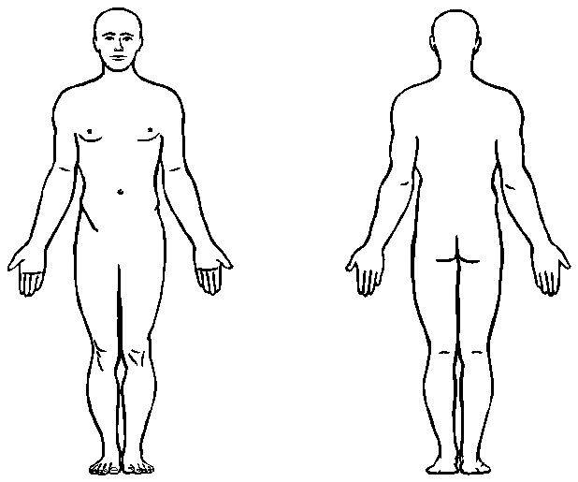
Part of body affected (circle all that apply)

Nature of Injury (check all that apply)

☐ Abrasion, Scrapes
☐ Amputation
☐ Broken Bone(s)
☐ Bruise
☐ Burn (Heat)
☐ Burn (Chemicals)
☐ Concussion (to the Head)
☐ Crushing Injury
☐ Cut, Laceration, Puncture
☐ Damage to a Body/System
☐ Hernia
☐ Illness
☐ Sprain, Strain
☐ Other: Click or tap here to enter text.

Unsafe Workplace Conditions (check all that apply)

☐ Inadequate Guard
☐ Unguarded Hazard
☐ Safety Device is Defective
☐ Tool or Equipment Defective
☐ Workstation Layout is Hazardous
☐ Unsafe Lighting
☐ Unsafe Ventilation
☐ Lack of Needed Personal Protective Equipment
☐ Lack of Appropriate Equipment or Tools
☐ Unsafe Clothing
☐ No Training or Insufficient Training
☐ Other: Click or tap here to enter text.

Unsafe Acts by People (check all that apply)

☐ Operating Without Permission
☐ Operating at Unsafe Speed
☐ Servicing Equipment with Power on
☐ Making a Safety Device Inoperative
☐ Using Defective Equipment
☐ Using Equipment in an Unapproved Way
☐ Unsafe Lifting
☐ Taking an Unsafe Position or Posture
☐ Distraction, Teasing, Horseplay
☐ Failure to Wear Persona Protective Equipment
☐ Failure to Use the Available Equipment or Tools
☐ Others:

Why did the unsafe conditions exist?
Click or tap here to enter text.

Why did the unsafe acts occur?
Click or tap here to enter text.

Is there a reward (such as “the Job can be done more quickly,” or “ the product is less likely to be damaged”) that may have encouraged the unsafe conditions or acts?
☐ Yes, describe below ☐ No
Click or tap here to enter text.

Were the unsafe acts or conditions reported prior to the incident? ☐ Yes ☐ No

Have there been similar incidents or near misses prior to this one? ☐ Yes ☐ No

What changes do you suggest to prevent this incident/near miss from happening again?

☐ Stop this activity ☐ Redesign task steps ☐ Routinely inspect for the hazard

☐ Guard the hazard ☐ Redesign workstation ☐ Personal Protective Equipment

☐ Train the employee(s) ☐ Write a new policy/rule ☐ Other

☐ Train the supervisor(s) ☐ Enforce existing policy If Other: Click or tap here to enter text.
What should be (or has been) done to carry out the suggestion(s) checked above?
Click or tap here to enter text.

Attachments (write number of attachments in space provided) | ☐ Written witness statements (Click or tap here to enter text.)  ☐Photographs (Click or tap here to enter text.)  ☐Maps / drawings (Click or tap here to enter text.)
Name & Title of supervisor preparing the report | Click or tap here to enter text.
Names of others on investigation team | Click or tap here to enter text.  Click or tap here to enter text.  Click or tap here to enter text.

Supervisors Signature:________________________________________________________________________________

Name (print): Click or tap here to enter text.

Date: Click or tap here to enter text.

Reviewer Signature: _________________________________________________________________________________

Name (print): Click or tap here to enter text.

Date: Click or tap here to enter text.

Form Created 1/31/22 srh

