DMI’s 15th Anniversary Celebration
Dinner Menu Selection Survey
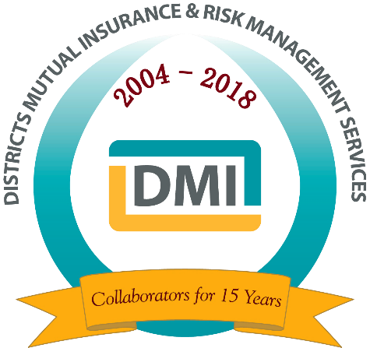
Attendee Information

Name:
Technical College:
If Other Organization:
Email Address:
Telephone Number:
Planning to Attend DMI’s 15th Anniversary Celebration Dinner
Thursday, April 11, 2019 – in Villa Gottfried Room B

Please indicate your choice of Dinner Entrée
Chicken and Steak Duxelle (Marinated & Seared Chicken Breast Stuffed with Wild Mushroom Duxelle, and Grilled 5 oz Angus Beef Tenderloin Topped with Duxelle Butter; served with Garden Salad, Boursin Whipped Potatoes, Seasonal Vegetable, and Red Wine Jus)

Prosciutto-Wrapped Pacific Halibut (Marinated with Extra Virgin Olive Oil, Fresh Lemon & Basil, Wrapped in Prosciutto; served with Creamy Lemon Risotto, Seasonal Vegetable, and Salsa Verde) (GLUTEN FREE)

Roasted Mushroom Ravioli (Ravioli with Mélange of Roasted Mushrooms & Ricotta Cheese, Seasonal Vegetable, Butter-Sautéed Baby Spinach with Porcini Mushroom Butter Sauce)

Please note special meal considerations (i.e. allergies):

Would you like to bring a spouse, significant other, or guest to dinner? Yes
Name of Guest:
Cost: $50.00 for Guest Dinner

Guest Dinner Entrée Selection: Chicken & Steak Duxelle
Prosciutto-Wrapped Halibut
Roasted Mushroom Ravioli

Please mail payment and a copy of this form for guest meal by March 29th to:
Districts Mutual Insurance, 212 W. Pinehurst Trail, North Sioux City, SD 57049.
This will allow DMI to confirm attendance counts for the DMI 15th Anniversary Dinner and Program.

